**Setting up Application Environment**

**Create an Account in Sendgrid**

|  |  |
| --- | --- |
| DATE | 3 NOVEMBER 2022 |
| TEAM ID | PNT2022TMID02998 |
| PROJECT NAME | SMART FASHION RECOMMENDER APPLICATION |
| TASK ASSIGNED TO | SAKTHIVEL C R |

**Step 1:**

Go to official Sendgrid website: [***https://sendgrid.com/***,](https://sendgrid.com/) then click start for free.



**Step 2:**

Then go to Registration Page, you need to give all the details required for creating a Sendgrid account and finally click create button. The below screenshot will show the registration Process.

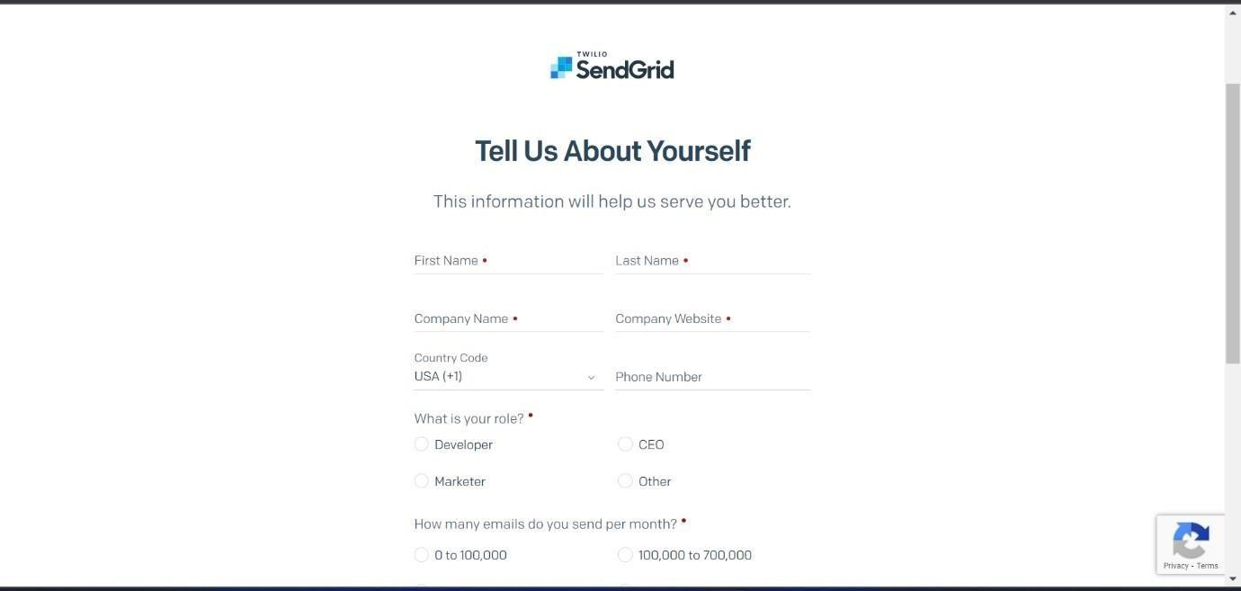

**Step 3:**

Then it will redirect you to a home page of your sendgrid account.

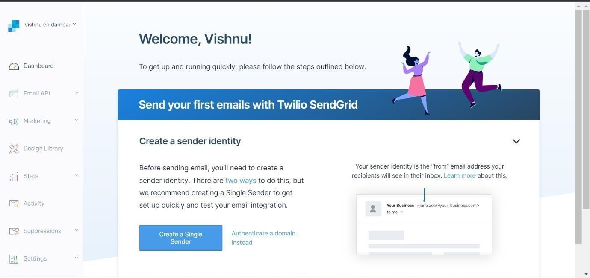

**Step 4:**

Finally, you have created your account and now you can access the sendgrid account.